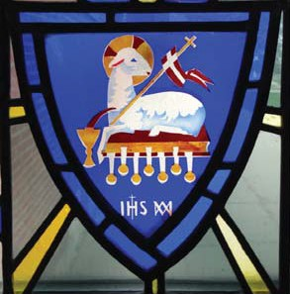**PRAYERS FOR VOCATIONS**

**Prayer for Precious Blood Vocations**

Lord God, You called St. Gaspar del Bufalo to

renew the Church through the ministry of the

Word and the Proclamation of our salvation

in Christ’s Precious Blood. Continue to call

men and women to share in that mission as

brothers, sisters, priests and companions who

respond to the cry of the Blood in our world

today. Give them the graces they need to

answer the call and live as your ever faithful servants. We ask this in the name of Jesus who shed his Blood for us.

Amen.

**Prayer for Ourselves and Our Vocations**

In the water of baptism, Lord God, Your

voice called out, “You are my beloved sons and

daughters, with whom I am well pleased.”

You breathed your Spirit upon us, and washed

us in the saving blood of the Lord. Open

our ears to hear Your Word, our minds to

understand Your call, our hearts to respond

faithfully. Give us courage to answer, strength

to persevere, and a willingness to be sent. We

ask this in the name of Jesus the Christ,

in whose blood we have been saved.

Amen.

**Vocation Prayer**

O God, You created me for a purpose, a

specific task for the Church and humanity.

You have always known the work I was cut

out for, a work which only I can do and no

other. If I do not accept this work, it will

never be done. Therefore, I have a job to do.

Make clear to me your will, and I will follow

you in whatever task this may be. I know I can

do all things in you, my strength.

Amen.

**Vocation Prayer**

Lord God, In Jesus Christ, you shared with us

the eternal Word! He took up his cross for our

salvation And invited us to take up the cross

and follow him. He shared the cup of his

Precious Blood with his disciples and shares it

with us each time we gather for Eucharist.

Help us to share in his mission, to proclaim

the Good News of our salvation to all the

world. Help us to share in his life as we live

out our faith each day. Give us his Spirit now

and always. We ask this in the name of Jesus

the Lord.

Amen!

**Vocation Prayer**

God, our Creator and Redeemer, by the blood

of your Son, you have brought all people

near. Raise up faithful ministers, especially

Priests, Brothers and Sisters for your Church;

so that the world may see the fallen lifted up

the old made new, and all things brought to

perfection through Him who is their origin,

our Lord Jesus Christ, who lives with you and

the Holy Spirit one God forever and ever.

Amen!



Missionaries of the Precious Blood [www.cpps-preciousblood.org](http://www.cpps-preciousblood.org/)