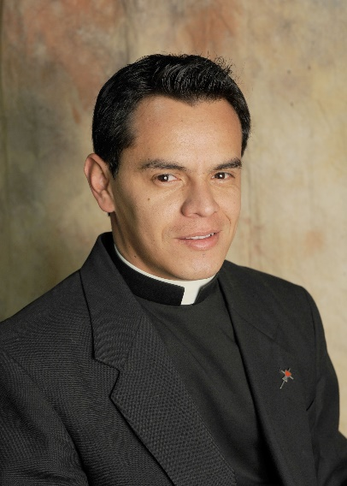The repose of the soul of Fr. Angelmiro Granados Acevedo, who died last night in an automobile accident. Fr. Angelmiro was a former C.PP.S. member who lived and ministered in Colombia. He died as a priest of the Diocese of Buga, Colombia. Fr. Angelmiro attended the Cincinnati Province Assembly in 2014. May he rest in peace, and may the peace of Christ be with his family.

The repose of the soul of Sr. Maureen Mangen, CPPS, who died on July 11. Viewing will be held from 9:15 a.m. until 10 a.m. on Wednesday in the sisters' Salem Heights Chapel in Dayton, followed by a 10 a.m. Mass of Christian Burial. May she rest in peace.

